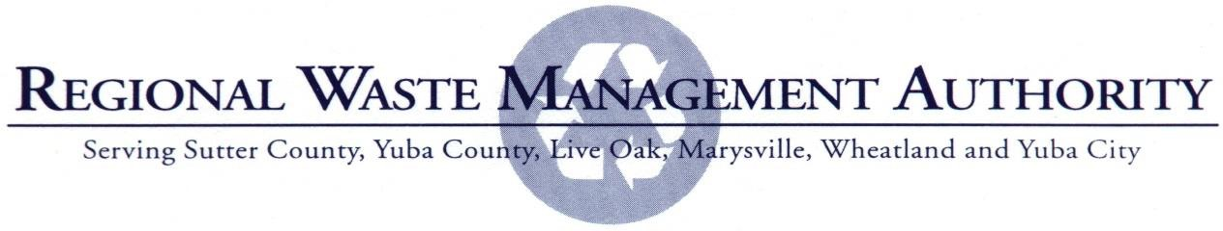

MEETING NOTICE & AGENDA

DATE: July 18, 2024

TIME: 4:30 p.m.

PLACE: Yuba County Government Center Marysville Room
915 Eighth Street Marysville, California

- Call to Order & Roll Call

Bains (Chairman), Buttacavoli, Shaw (Vice-Chairman), Teeter, Woten and Blaser

- Public Business from the Floor
Members of the public may address the Authority on any item listed on the agenda prior to the convening of the closed session. No action may be taken on items that do not appear on the posted agenda. No member of the public will be allowed to be present once the Authority convenes into closed session.

- Consent Calendar

All matters listed under the Consent Calendar are considered to be routine and can be enacted in one motion. There will be no separate discussion of these items prior to the time the Board votes on the motion unless members of the Board, staff, or public request specific items to be discussed or removed from the Consent Calendar for specific action.

  - Approval of minutes from May 28th meeting (Attachment)
  - Disbursement List for May/June 2024. (Attachment)

- Reports

  - Local Agency Investment Fund (LAIF) Signature Authority Title Change (Attachment)

RECOMMENDATION: Adopt Resolution No. 1-24 changing the authorized signers on the Regional Waste
Management Authority’s LAIF account as proposed or revised.
  - California Department of Resources Recycle and Recovery (CalRecycle) Used Oil Payment Program Application for FY 2024/2025 (OPP Cycle 15) (Attachment)

RECOMMENDATION: Adopt Resolution No. 2-24 authorizing the submittal of a regional application for the CalRecycle Used Oil Payment Program Cycle 15 for FY 2024/2025 as proposed.

  - Local Government Waste Tire Amnesty Grant Program (TA6 Cycle, FY 2021/22) (Attachment)
RECOMMENDATION: Adopt Resolution No. 3-24 extending the expiration of Resolution No. 1-21 authorizing the submittal and administration of a regional application under the Local Government Waste Tire Amnesty Grant Program (TA6 Cycle, FY 2021/22).
- Other Business

- Adjournment

THE NEXT REGULAR MEETING IS SCHEDULED FOR 4:30 P.M. ON THURSDAY, AUGUST 15, 2024 IN THE YUBA COUNTY BOARD OF SUPERVISORS CHAMBERS.

AGENDA ITEM III-A
REGIONAL WASTE MANAGEMENT AUTHORITY MEETING MINUTES
May 28, 2024

- Call to Order & Roll Call

The meeting was called to order by Chairman Bains at 1:15 p.m. Present: Shaw, Woten, Teter, Blaser, Buttacavoli, and Bains
- Public Business from the Floor
None.

- Closed Session

  - PUBLIC EMPLOYMENT (Pursuant to Government Code Section 54597) Position Title: Executive Director
There was nothing to report out of the closed session.
- Reports

  - Regional Waste Management Authority Budget for FY25 (Attachment)
Recommendation: Adopt the FY25 Budget as proposed
Director Shaw made a motion to approve the FY25 Budget. Director Buttacavoli seconded the motion, and it was carried unanimously.

  - Administrative Staff Cost of Living Salary Adjustments (Attachment)

Recommendation:: Approve the staff cost of living salary adjustments and adopt the resulting salary schedule effective July 1, 2024, as proposed, or amended.
The Board agreed to table this action until an Executive Director is hired. No action was taken.
  - Executive Director Employment Agreement: Consideration to enter into an agreement to have a consulting firm serve as the temporary executive director.
Director Shaw made a motion to approve R3 into an agreement as a temporary executive director. Director Blaser seconded the motion, and it was carried unanimously.
Director Buttacavoli made a motion to approve MRG into an agreement. Director Blaser seconded the motion, and it was carried unanimously.

- Other Business
None.
- Adjournment
The meeting was adjourned at 1:54pm

THE NEXT REGULAR MEETING IS SCHEDULED FOR 4:30 P.M. ON THURSDAY, June 20, 2024 IN THE YUBA COUNTY BOARD OF SUPERVISORS CHAMBERS.

AGENDA ITEM III-B

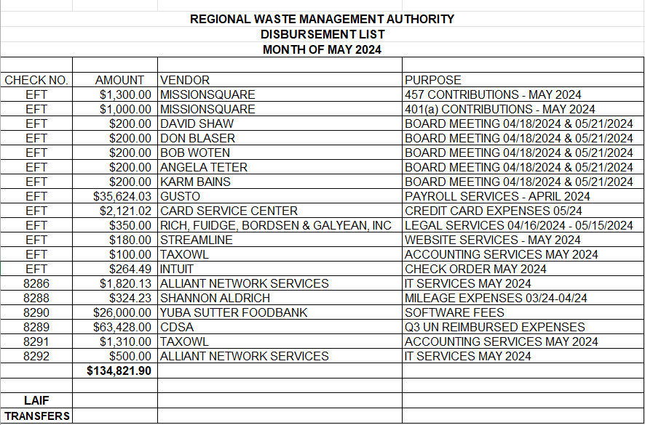

REGIONAL WASTE MANAGEMENT AUTHORITY DISBURSEMENT LIST
MONTH OF JUNE 2024
CHECK NO | AMOUN | VENDOR | PURPOSE
EFT | $ 1 300.00 | MISSIONSQUARE | 457 CONTRIBUTIONS - JUNE 2024
EFT | $ 1 000.00 | MISSIONSQUARE | 401/a) CONTRIBUTIONS - JUNE 2024
EFT | $ 100.00 | DAVID SHAW | BOARD MEETING 05/28/2024
EFT | $ 100.00 | DON BLASER | BOARD MEETING 05/28/2024
EFT | $ 100.00 | BOB WOTEN | BOARD MEETING 05/28/2024
EFT | $ 100.00 | ANGELA TETER | BOARD MEETING 05/28/2024
EFT | $ 100.00 | KARM BAINS | BOARD MEETING 05/28/2024
EFT | $1 280.00 | RICH FUIDGE BORDSEN & GALYEAN INC | LEGAL SERVICES 05/16/2024 - 06/15/2024
EFT | $43 485.31 | GUSTO | PAYROLL SERVICES - JUNE 2024
EFT | $360.00 | STREAMLINE | WEBSITE SERVICES - DECEMBER 2023/JUNE 2024
8287 | $ 7 656.42 | SUTTER COUNTYHUMAN RESOURCES | RWMA JUNE 2024 BENEFITS
8295 | $ 170.96 | SHANNON ALDRICH | APRIL-MAY 2024 MILEAGE
8296 | $ 300.00 | BRUCE BUTTACAVOLI | RWMA BOARD MEETING APRIUMAY 2024
8297 | $ 500.00 | ALLIANT NETWORK SERVICES | IT SERVICES JUNE 2024
 | $56,552.69
LAIF
RANSFERS

AGENDA ITEM IV-A

Staff Report

LOCAL AGENCY INVESTMENT FUND (LAIF) SIGNATURE AUTHORITY TITLE CHANGES

Staff is requesting a change in signature authority for Regional Waste Management Authority’s Local Agency Investment Fund (LAIF) account to reflect the staff and titles that have changed since the current authorizing resolution was adopted in May 2023. The Administrator and Finance Program Manager, or their successors in office, are the currently authorized positions under the consulting agreement between the Regional Waste Management Authority and Yuba-Sutter Transit. The attached resolution would simply replace the contracted Administrator position with the new Interim Executive Director position for this purpose.

Staff will be prepared to discuss this issue in more detail at the meeting.

RECOMMENDATION: Adopt Resolution No. 1-24 changing the authorized signers on the Regional Waste Management Authority’s LAIF account as proposed or revised.

Attachment

REGIONAL WASTE MANAGEMENT AUTHORITY RESOLUTION NO. 1-24
AUTHORIZING INVESTMENT OF MONIES IN THE LOCAL AGENCY INVESTMENT FUND

WHEREAS, The Local Agency Investment Fund is established in the State Treasury under Government Code section 16429.1 et. seq. for the deposit of money of a local agency for purposes of investment by the State Treasurer; and

WHEREAS, the Regional Waste Management Authority Board of Directors hereby finds that the deposit and withdrawal of money in the Local Agency Investment Fund in accordance with Government Code section 16429.1 et. seq. for the purpose of investment as provided therein is in the best interests of the Authority.

NOW, THEREFORE, BE IT RESOLVED that the Board of Directors hereby authorizes the deposit and withdrawal of Authority monies in the Local Agency Investment Fund in the State Treasury in accordance with Government Code section 16429.1 et. seq. for the purpose of investment therein.

BE IT FURTHER RESOLVED, as follows:
Section 1. The following Regional Waste Management Authority officers holding the title(s) specified hereinbelow or their successors in office are each hereby authorized to order the deposit or withdrawal of monies in the Local Agency Investment Fund and may execute and deliver any and all documents necessary or advisable in order to effectuate the purposes of this resolution and the transactions contemplated hereby:

1. Carrie Baxter  Interim Executive Director/ Executive Director | 2. Simone Reed  Finance Program Manager/ Finance Manager
Section 2. This resolution shall remain in full force and effect until rescinded by the Board of Directors by resolution and a copy of the resolution rescinding this resolution is filed with the State Treasurer’s Office.

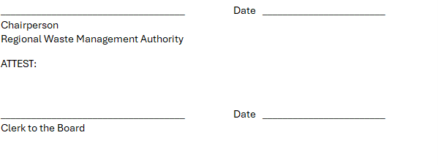
The foregoing resolution was passed by the Regional Waste Management Authority this 18 day of July 2024. Effective July 18, 2024.

AGENDA ITEM IV-B

REGIONAL WASTE MANAGEMENT AUTHORITY

Staff Report

CALIFORNIA DEPARTMENT OF RESOUCES RECYCLING AND RECOVERY (CALRECYCLE) USED OIL PAYMENT PROGRAM APPLICATION FOR FY 2024/2025 (OPP CYCLE 15)

The California Department of Resources Recycling and Recovery (CalRecycle) released the on-line application for the Used Oil Payment Program (OPP Cycle 15) for FY 2023/2024 and applications were due by June 26th. Staff is now requesting that the Board adopt the attached resolution authorizing the submittal of this regional funding application. With the RWMA as the Lead Agency, letters of authorization are not required from the member agencies to participate in this regional program. July 24th is the latest date by which the Board resolution is required to be submitted.

The minimum funding amounts for small jurisdictions is expected to continue to be the same as for past cycles: $5,000 for cities and $10,000 for counties. Live Oak, Marysville, Wheatland, and Sutter County would all receive the applicable minimum amount. Funding amounts for larger jurisdictions are calculated on a per capita basis. While Yuba City and Yuba County would usually receive higher amounts, these jurisdictions are projected to receive slightly over $10,000 each because the amount of funding available has been reduced since the pandemic. The combined funding amount for all six of the RWMA jurisdictions in Fiscal Year 2023/2024 cycle was $45,082 compared to pre-pandemic cycles that were approximately $60,000 per year. The final amount will be provided by CalRecycle following receipt of all of the applications.
The following conceptual work program and budget based on a reduced funding projection of $45,000 is now being presented for review by the Board. Should the final funding amount be greater than projected, the additional funds will be used to fund additional public education activities.

OPP Cycle 15 Used Oil Payment Program – Proposed Projects and Budget

Public education and information to promote used oil and oil filter recycling. | $2,500
Support the English as a Second Language (ESL) teacher training program based on the number of teachers that participate. | $1,000
Fund the used oil and oil filter collection and recycling costs at the Yuba-Sutter Household Hazardous Waste Facility. | $39,000
Coordination of the public education and information campaign and grant management and administration. | $2,500

TOTAL | $45,000

Staff will be prepared to review this project in detail at the meeting.

RECOMMENDATION: Adopt Resolution No. 2-24 authorizing the submittal of a regional application for the CalRecycle Used Oil Payment Program Cycle 15 for FY 2024/2025 as proposed.

Attachment

REGIONAL WASTE MANAGEMENT AUTHORITY RESOLUTION NO. 2-24
CALIFORNIA DEPARTMENT OF RESOURCES RECYCLING AND RECOVERY (CALRECYCLE) USED OIL PAYMENT PROGRAM CYCLE 15, FY 2024/2025

WHEREAS, pursuant to Public Resources Code sections 48000 et seq., 14581, and 42023.1 (g), the Department of Resources Recycling and Recovery (CalRecycle) has established various payment programs to make payments to qualifying jurisdictions; and

WHEREAS, in furtherance of this authority Cal Recycle is required to establish procedures governing the administration of the payment programs; and

WHEREAS, the payment program allows regional participation; and

WHEREAS, CalRecycle's procedures for administering payment programs require, among other things, a regional applicant's governing body to declare by resolution certain authorizations related to the administration of the payment programs.

NOW, THEREFORE, BE IT RESOLVED that the Regional Waste Management Authority is authorized to submit a Used Oil Payment Program regional application for Cycle 15, FY 2024/2025, on behalf of itself as Lead Agency and the following participants: Cities of Live Oak, Marysville, Wheatland and Yuba City and the Counties of Yuba and Sutter; and

BE IT FURTHER RESOLVED that the Executive Director, or his/her designee, is hereby authorized as Signature Authority to execute all documents necessary to implement and secure payment under the Oil Payment Program; and

BE IT FURTHER RESOLVED that this Resolution is effective until August 15, 2026.

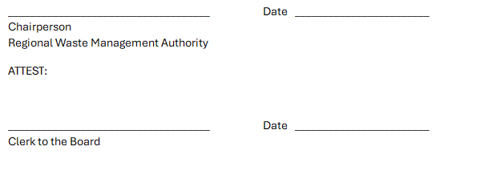

The foregoing resolution was passed by the Regional Waste Management Authority this 18 day of July 2024.

AGENDA ITEM IV-C

Agenda Item IV. – C Staff Report
LOCAL GOVERNMENT WASTE TIRE AMNESTY GRANT PROGRAM (TA6 CYCLE, FY 2021/22)
The California Department of Resources Recycling and Recovery (CalRecycle) issued the application package for the Local Government Waste Tire Amnesty Grant Program in March of 2021. A total of $1.25 million is available for this grant program with a maximum award of $40,000 per individual applicant (i.e., jurisdiction or JPA) and $90,000 for regional applicants (i.e., lead agency plus additional participating agencies). The RWMA has long received funding under this grant program which is available on a competitive basis for eligible projects to be completed during the two-year period, September 2021 through October 2023. A total of $33,460 was awarded to the RWMA in 2021. The grant was extended an additional year with final reporting due October 31, 2024.

Staff will be prepared to review this project in detail at the meeting.

RECOMMENDATION: Adopt Resolution No. 3-24 extending authorization of Resolution No. 1-21 through December 31, 2024.

Attachment

REGIONAL WASTE MANAGEMENT AUTHORITY RESOLUTION NO. 3-24
LOCAL GOVERNMENT WASTE TIRE AMNESTY GRANT PROGRAM (TA6 CYCLE, FY 2021/22)
Whereas, the California Public Resources Code authorizes the Department of Resources Recycling and Recovery (CalRecycle) to administer various Grant Programs; and

Whereas, in furtherance of this authority, CalRecycle is required to establish procedures governing the administration of the Grants; and

WHEREAS, CalRecycle grant application procedures require, among other things, a Lead Participant’s governing body to declare by resolution certain authorizations related to the administration of CalRecycle Grants.

WHEREAS, the Regional Waste Management Authority authorized the submittal of an application to CalRecycle for a Local Government Waste Tire Amnesty Grant Program (TA6 Cycle, FY 2021/22) through Resolution No 1-21 on April 15, 2021.
NOW, THEREFORE, BE IT RESOLVED that the Regional Waste Management Authority authorizes the submittal of an application to CalRecycle for a Local Government Waste Tire Amnesty Grant Program (TA6 Cycle, FY 2021/22).

BE IT FURTHER RESOLVED that the Executive Director of the Regional Waste Management Authority, or designee, is hereby authorized and empowered to execute on behalf of the Regional Waste Management Authority all necessary grant related documents, including, but not limited to, applications, agreements, amendments and requests for payment, necessary to secure grant funds and to implement the approved grant project; and
BE IT FURTHER RESOLVED that the Regional Waste Management Authority extends these authorizations effective through December 31, 2024.

The foregoing resolution was passed by the Regional Waste Management Authority this 18 day of July 2024.

Chairperson
Regional Waste Management Authority

ATTEST:
Date

Date
Clerl<to the Board

